ASSIGNMENT 6.4
NAME: N SAI TEJA
ROLL NO: 2403A51336
DATE:10/9/25

Task Description 1:
Start a Python class named Student with attributes name, roll_number, and marks. Prompt
GitHub Copilot to complete methods for displaying details and checking if marks are above
average.
Expected Outcome #1:
Completed class with Copilot-generated methods like display_details() and is_passed(),
demonstrating use of if-else conditions
CODE:
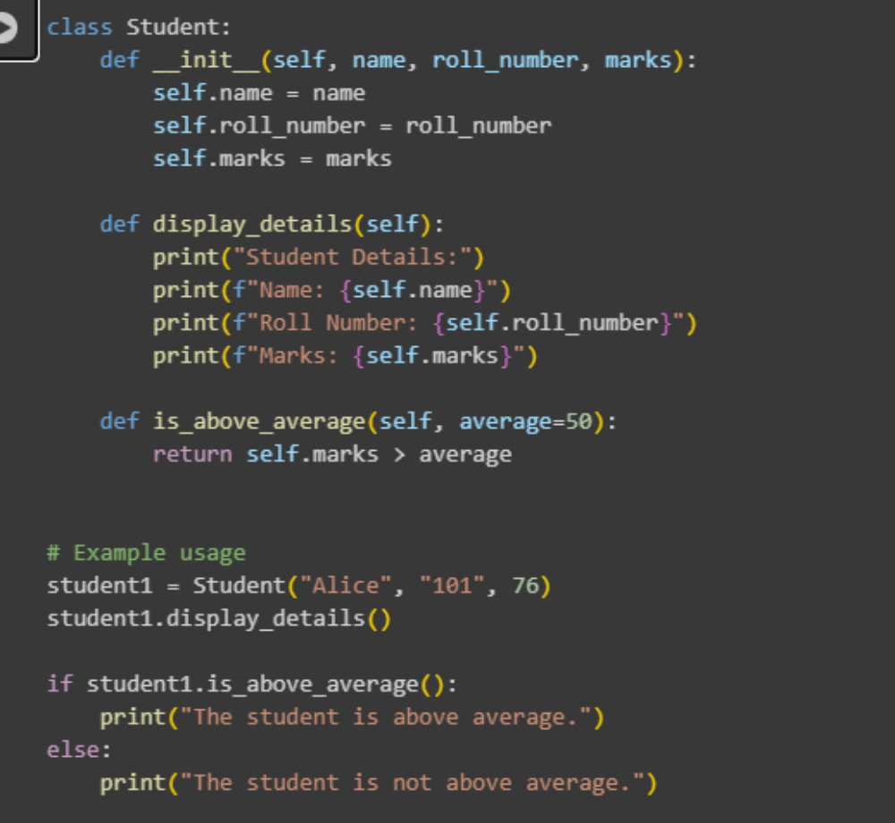
OUTPUT:
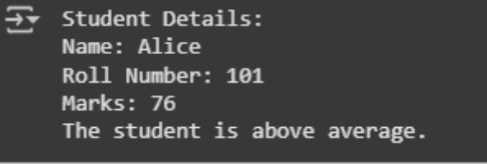
OBSERVATION:
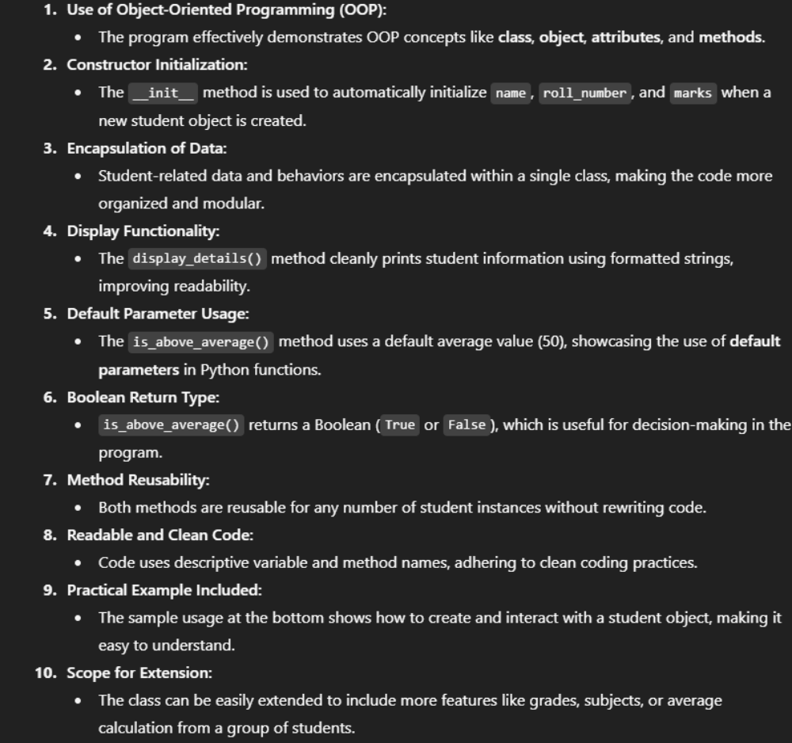
Task Description :2
Write the first two lines of a for loop to iterate through a list of numbers. Use a comment
prompt to let Copilot suggest how to calculate and print the square of even numbers only.
Expected Outcome #2:
A complete loop generated by Copilot with conditional logic (if number % 2 == 0) and
appropriate output
CODE:
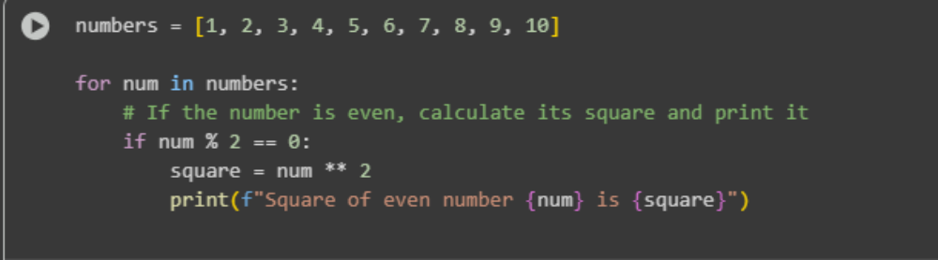
OUTPUT:
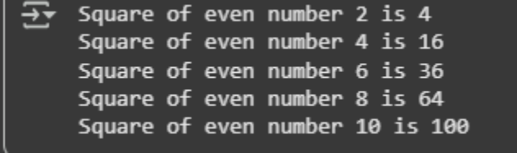
OBSERVATION:
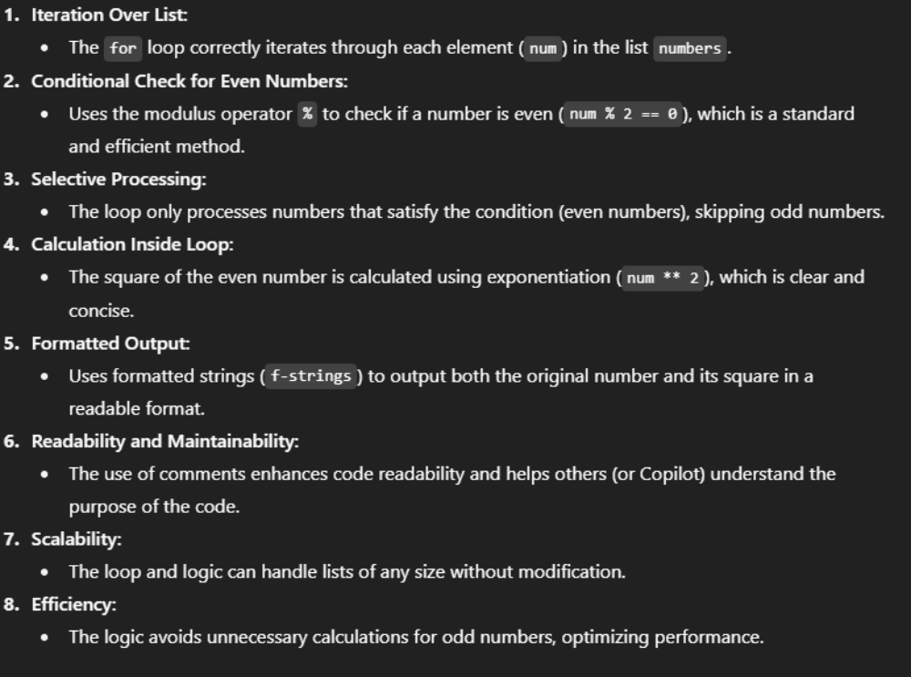
Task Description:3
Create a class called BankAccount with attributes account_holder and balance. Use Copilot to
complete methods for deposit(), withdraw(), and check for insufficient balance.
Expected Outcome #3:
Functional class with complete method definitions using if conditions and self attributes. Code
should prevent overdrawing.
CODE:
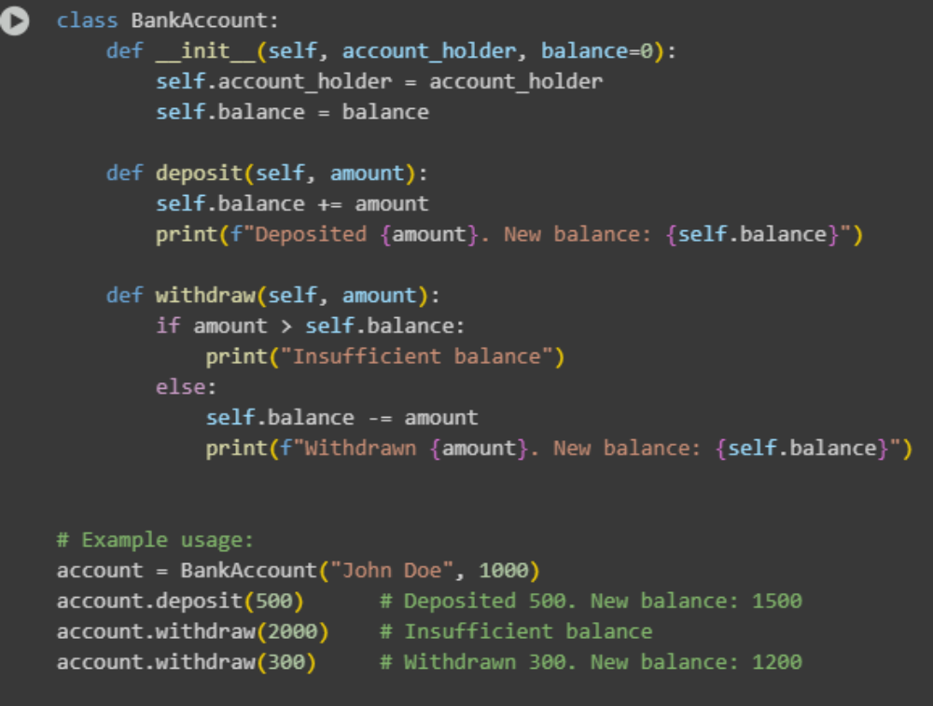
OUTPUT:
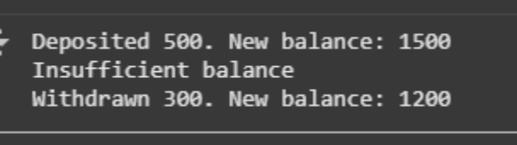
OBSERVATION:
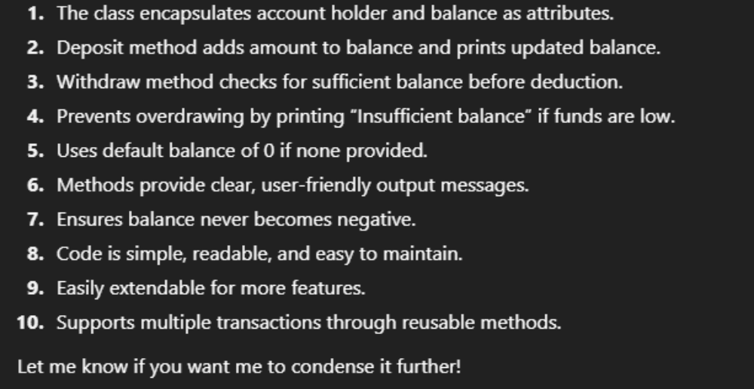
Task Description :4
Define a list of student dictionaries with keys name and score. Ask Copilot to write a while
loop to print the names of students who scored more than 75.
Expected Outcome #4:
A complete while loop generated by Copilot with proper condition checks and formatted
output
CODE:
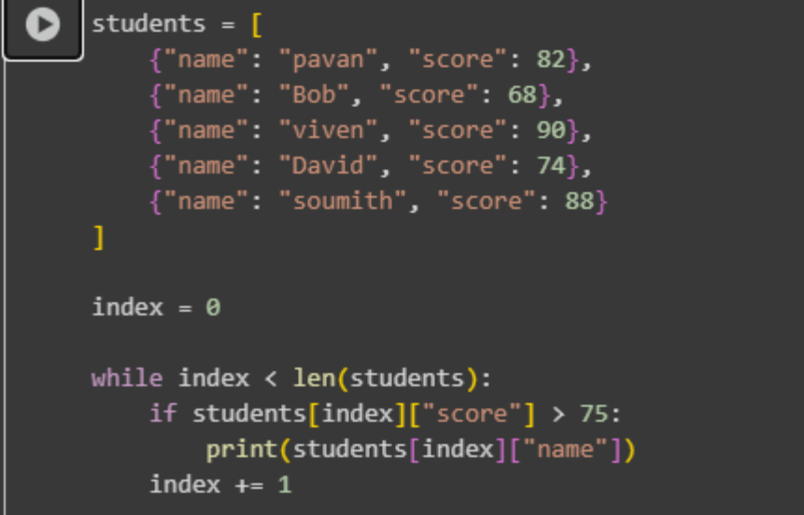
OUTPUT:
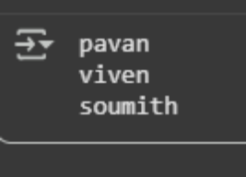
OBSERVATION:
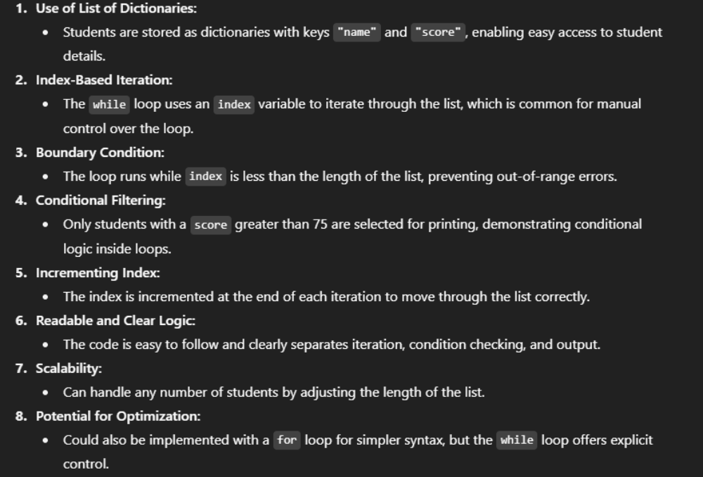
Task Description:5
Begin writing a class ShoppingCart with an empty items list. Prompt Copilot to generate
methods to add_item, remove_item, and use a loop to calculate the total bill using conditional
discounts.
Expected Outcome #5:
A fully implemented ShoppingCart class with Copilot-generated loops and if-else statements
handling item management and discount logic

CODE:
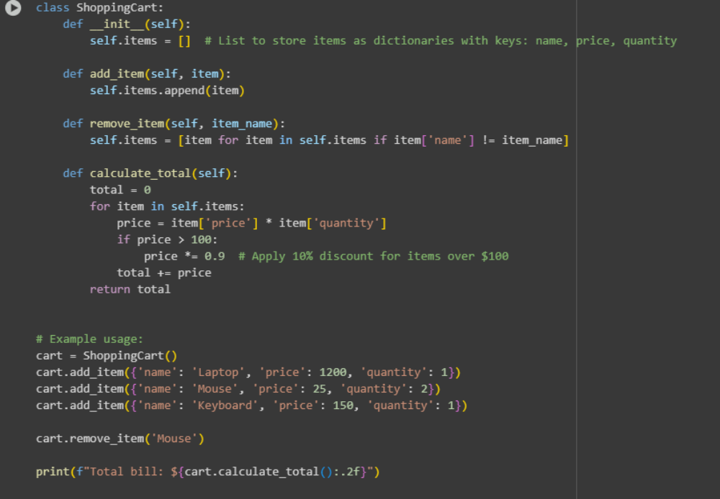
OUTPUT:
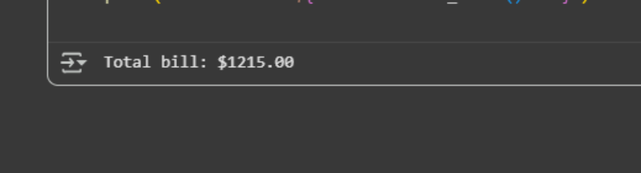
OBSERVATION:
